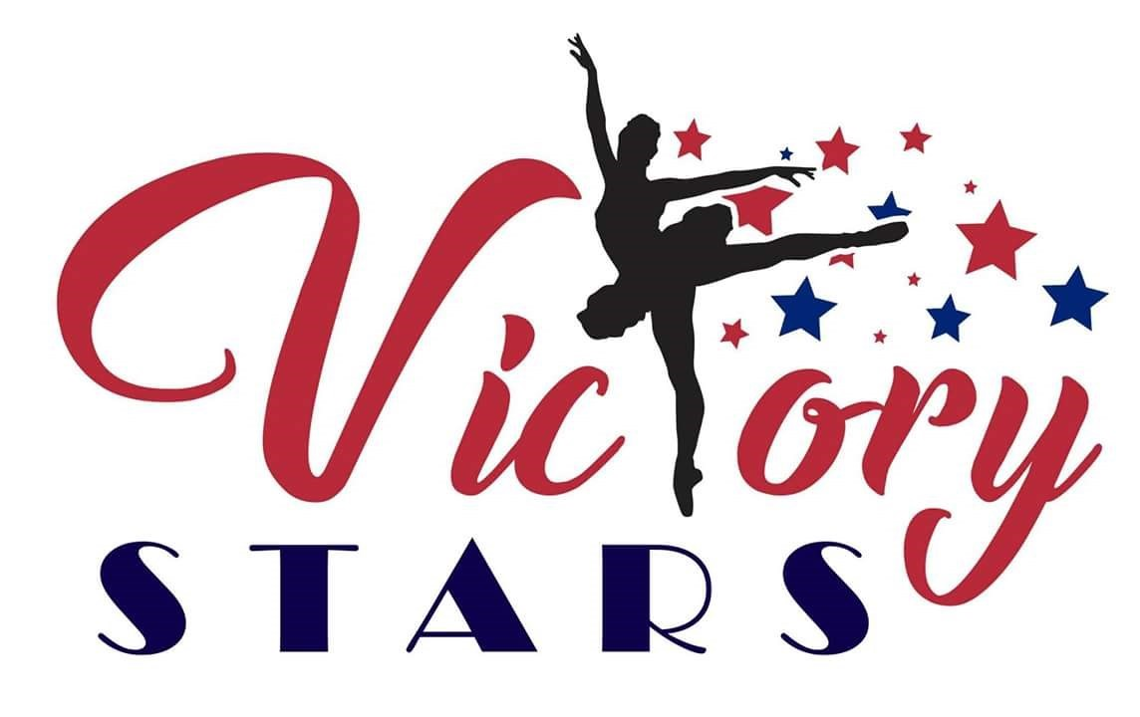

Victory Stars dance would like to welcome you to our program. We are excited to have your family join us and begin (or continue) your journey in the art of dance. The next ‘step’ would be to stop by & pick up the dance program information packet before classes begin at the Victory Villa Community Center @ 404 Compass Road on Tuesday, 9/6/2022; Wednesday, 9/7/2022; or Thursday, 9/8/2022 from 6-8pm. These will be the only days & times available – approval of class day & time will be verified during this time. Our dance program will be outlined along with details about upcoming events, fees, fundraisers, attire requirements and our goals for the upcoming dance year. Check out our facebook page MRVictoryStars or email us @ mrvictorystars@gmail.com if there are any questions, comments or concerns. Thank You!!

